BM 538

Computational Neuroscience

Project 4

Neural Data Analysis: Encoding

Experimentor:

Kerem Kurban

Submitted to:

Sevgi Öztürk

Burak Güçlü

**Results**

The aim of this project was to find the tuned neurons for a certain direction in the motor cortex of the macaque monkey by utilizing raster and peri-stimulus time histogram plots. The data was enormous therefore only a few of them will we shown in this report. In *figure 1*, the raster plot of channel 77-2 is plotted, for both 0.5 sec before and after the ‘go’ cue and 0-1 sec interval. We can differentiate the direction the neuron more responsive by looking the densities in each plot. There seems to be a increased density in the bottom right side.

However, this is not a good representation in understanding a neuron’s response to a certain direction. To get a better visualization, the data is divided into bins and the activation in each bin is shown in histogram like in the second row of the same figure*.* We can see the increase in firing rate in the same region (bottomright) and also there is an activation before go-cue comes, therefore supporting the hypothesis given in the book. By plotting the tuning curve, we can quantitatively visualize the exact angle where the neuron fired, which is appearently 281 degrees clockwise for the first figure. We can fit a function to the data in the tuning curve. Cosine function seems to be a good fit, with a mean error rates as low as 10-12. Tuning curves seem to be independent with respect to time points since the minimum and maximum firing rates are in the same region and the fitted function as well as its mean error rate are similar. In *figure 2*, we can see another channel where the tuning curves’ preffered direction is 304 and 316 degrees respectiveley which is at the same category among the 6 categories in 360 degrees, hence not different.

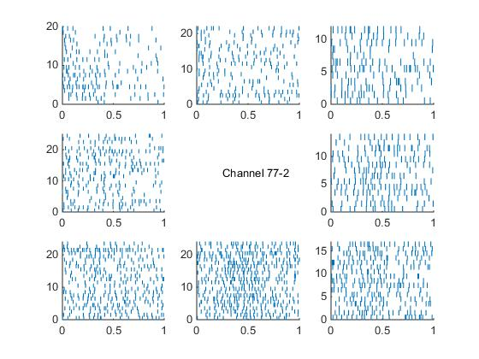

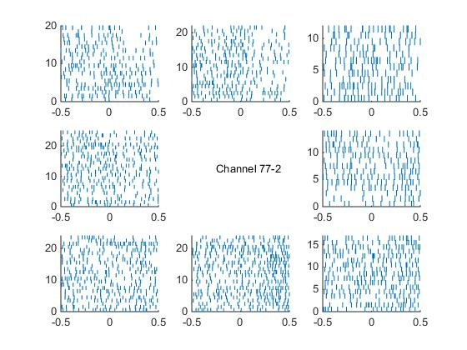

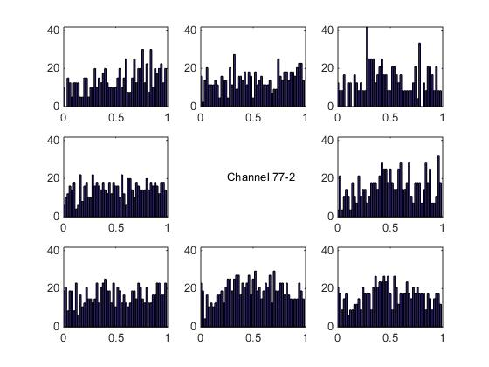

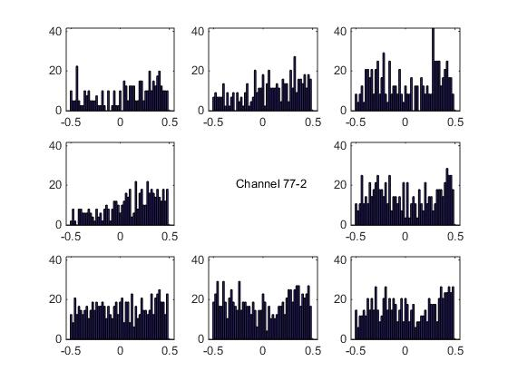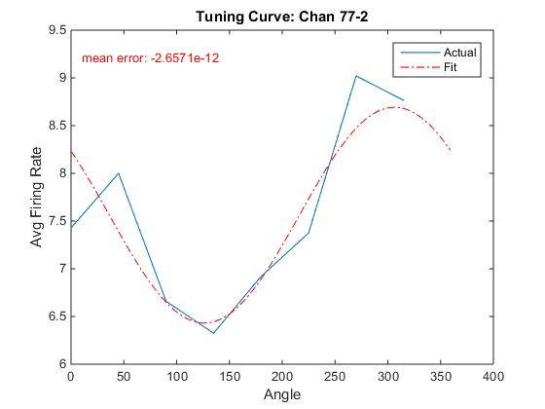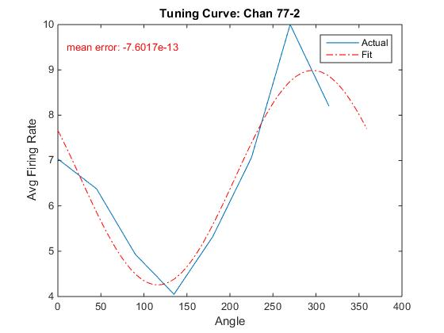

Figure 1: Raster plot , psth and Tuning curves of neuron 77-2. In Psth, 0 indicates the time of the go cue

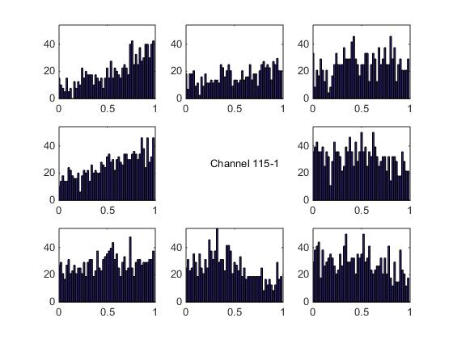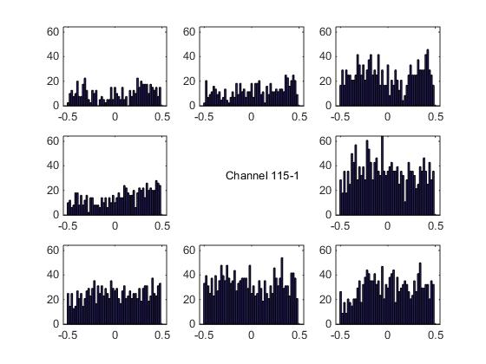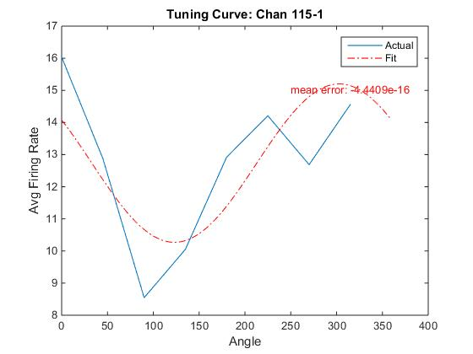

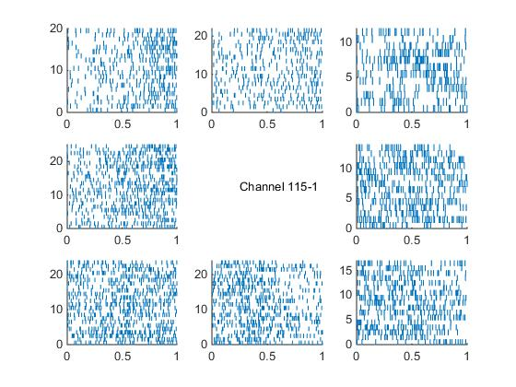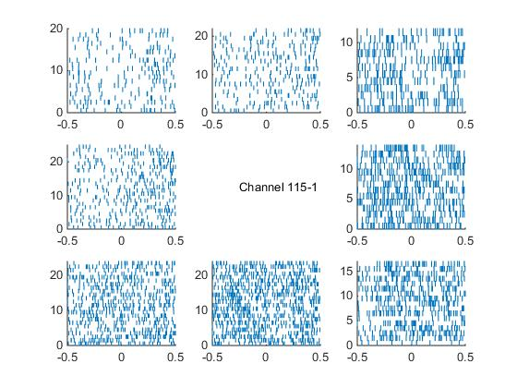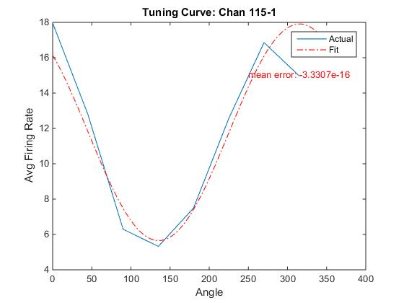

Figure 2: Raster plot , psth and Tuning curves of neuron 115-1. In Psth, 0 indicates the time of the go cue